**Exp 32**

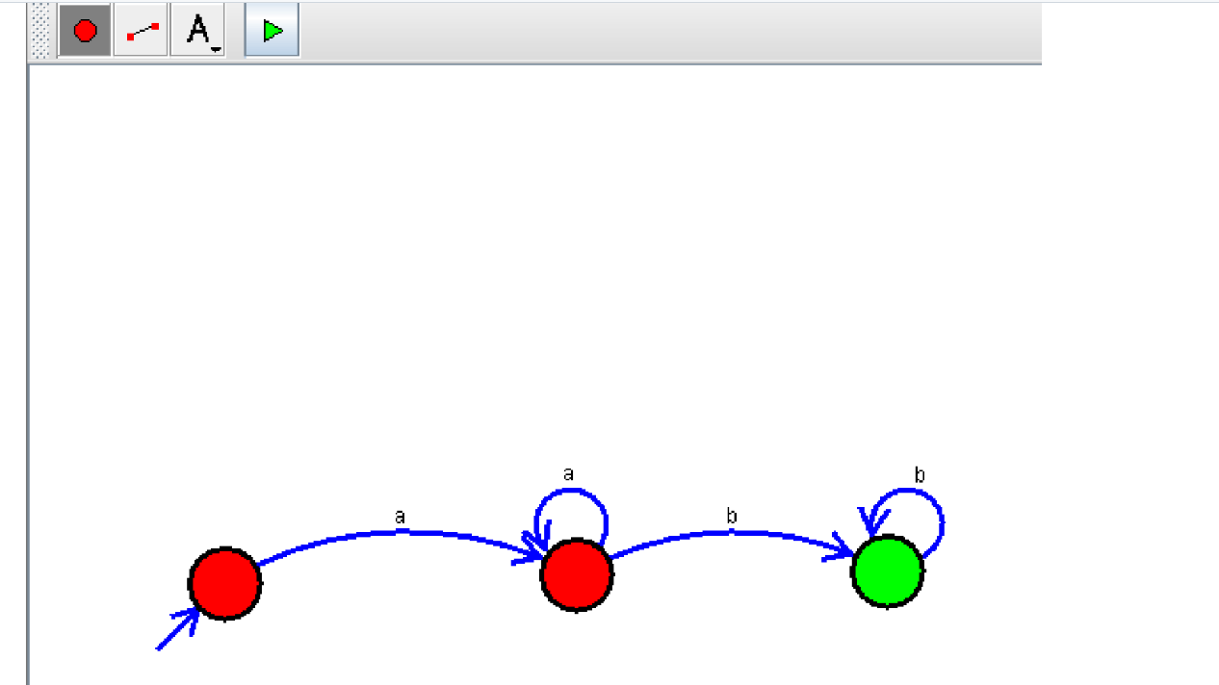

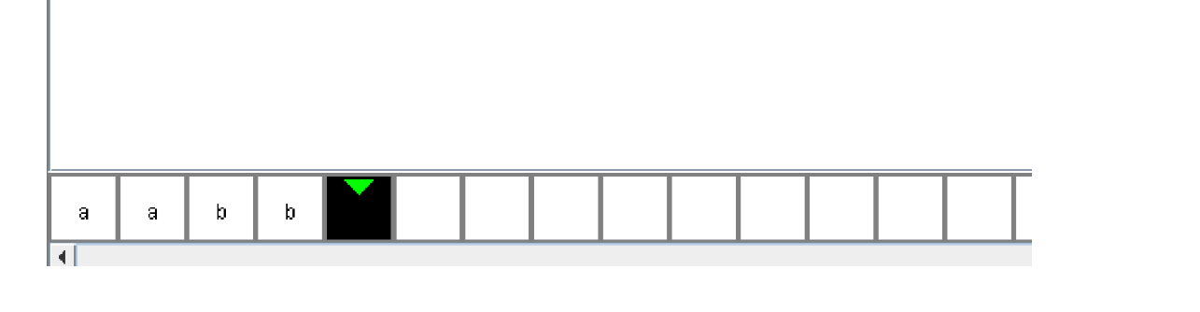

**Result:** Thus designing NFA transition diagram that start and end with different alphabets is done and verified by giving sample inputs.